**App: Online Course**

**Login/Register Page Design**

**Elements:**

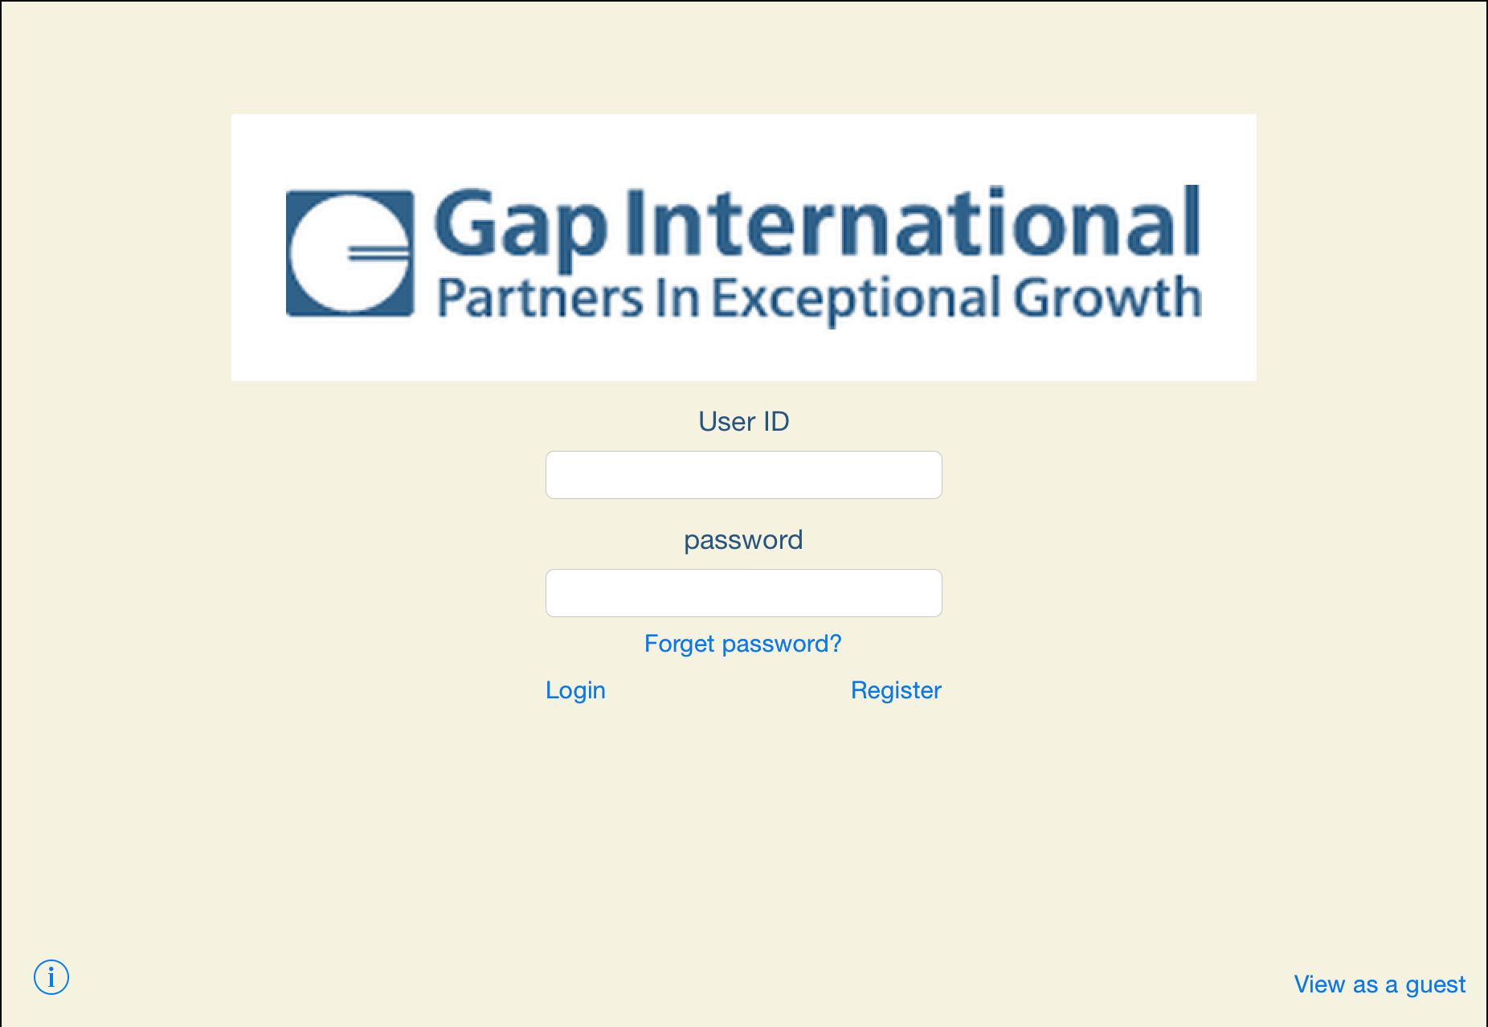Background: light yellow(the same as the website)

Company logo: middle on top, 638x166

“User ID” label and “password” label : blue text, size 20

“userID” input text field: size 14

“password” input text field: size 14, secure text entry

“login” button:

blue font, pop out a window, login and segue to video page

“register” button:

blue font, send request to register, pop out a window, login and segue to video page an account and segue to video page

“Foget password? “ button:

segue to Reset password page.

“i” (info) button: segue to and view the introduction.

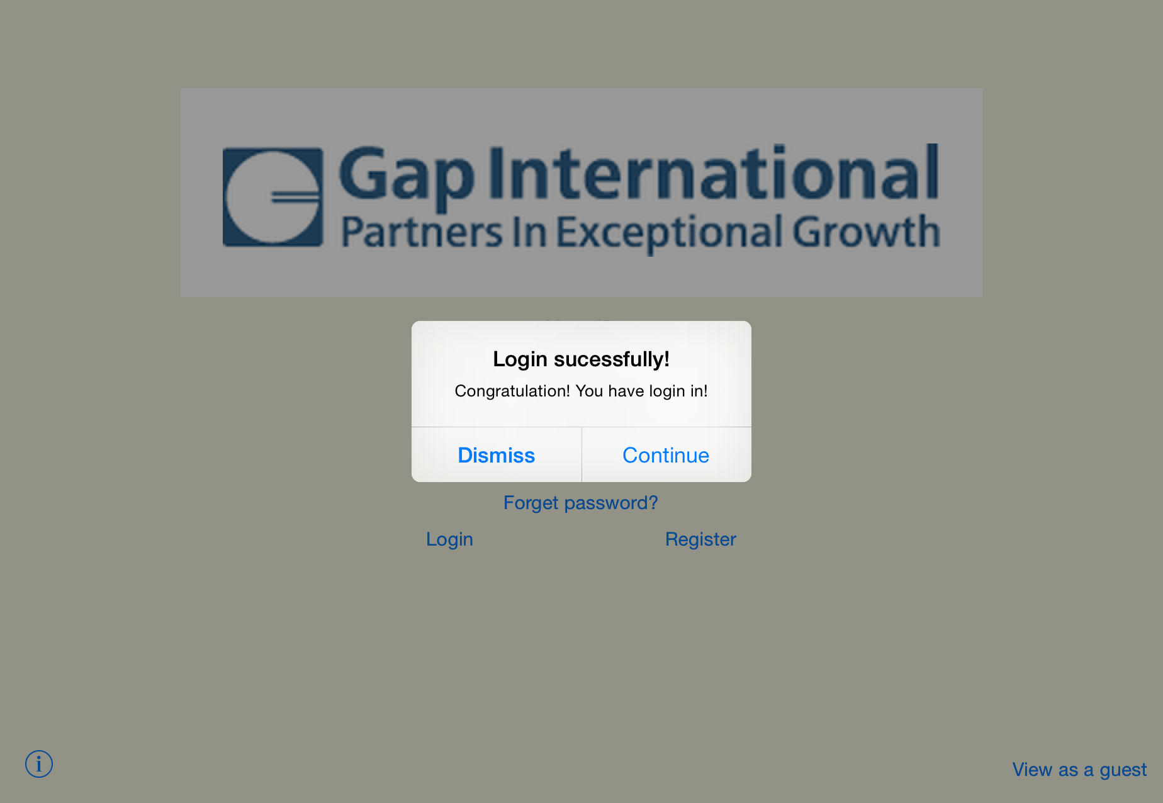

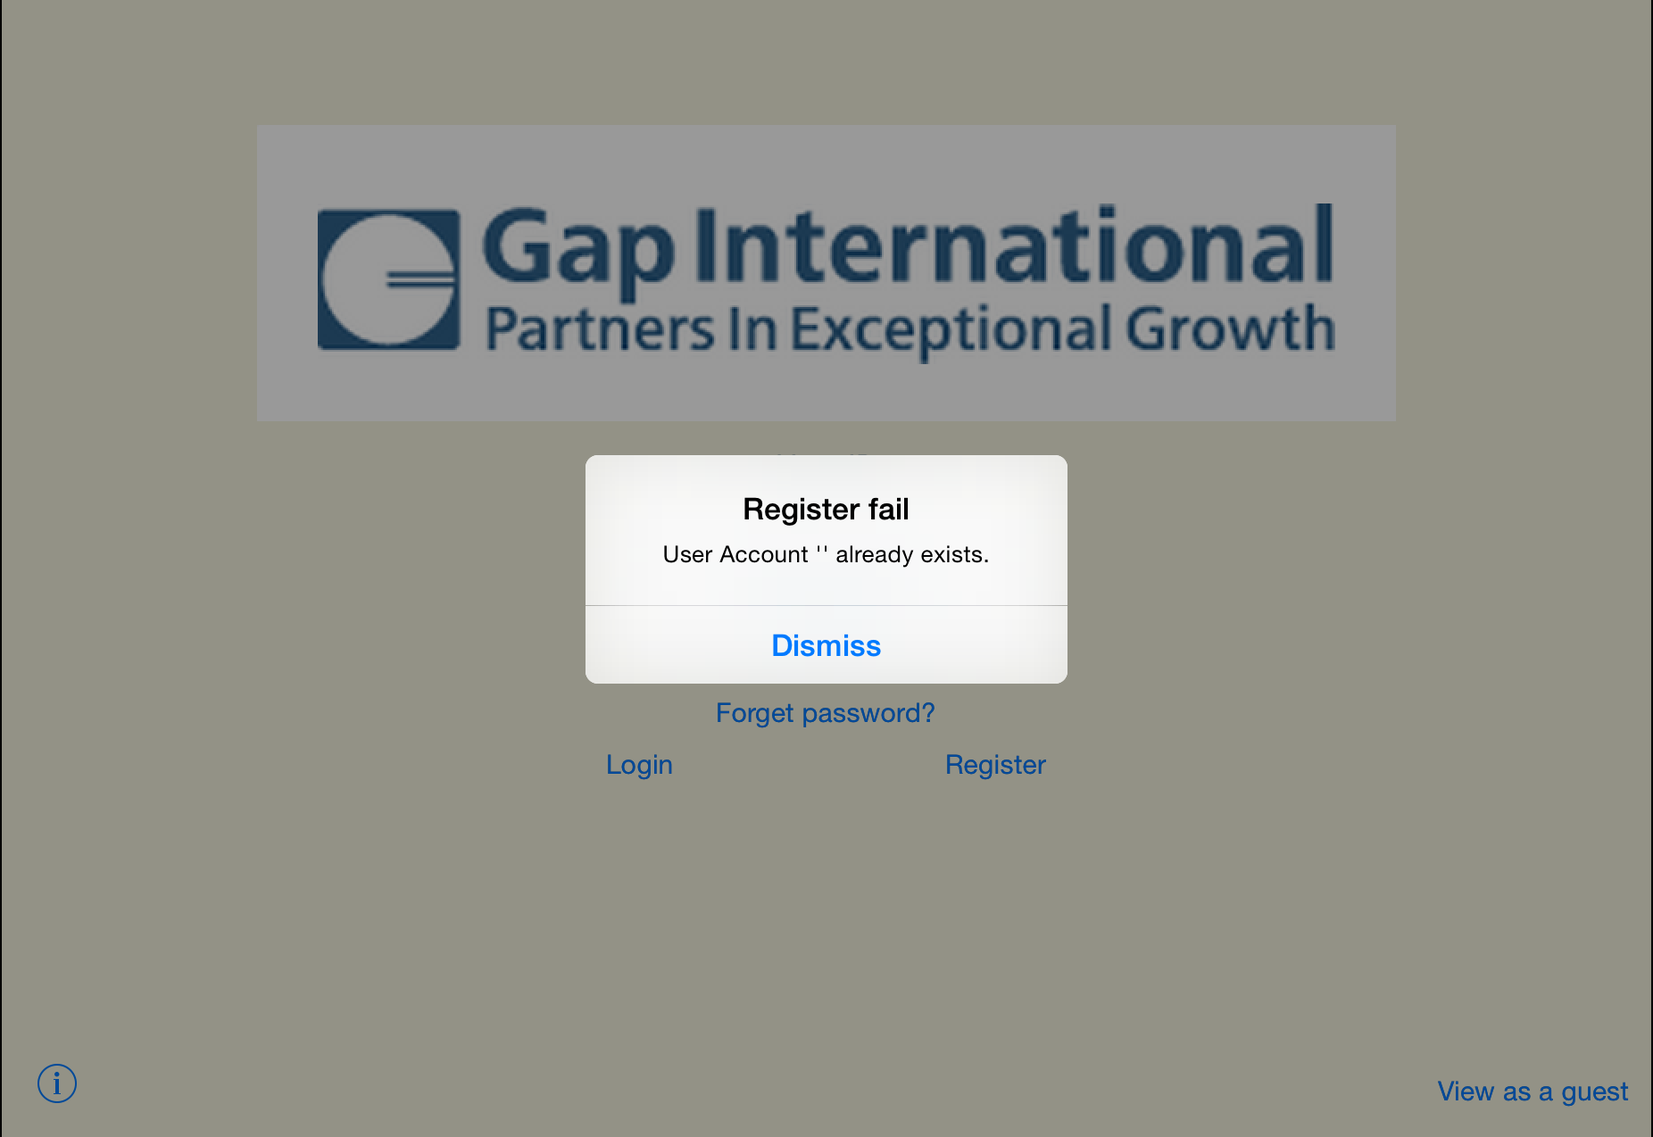

About Page Design

**Elements:**

Background: light yellow

Company logo: cut from the website

Motto: text in blue, size 18

About content:

font in black, size 14

“back” button: segue to the login or register page

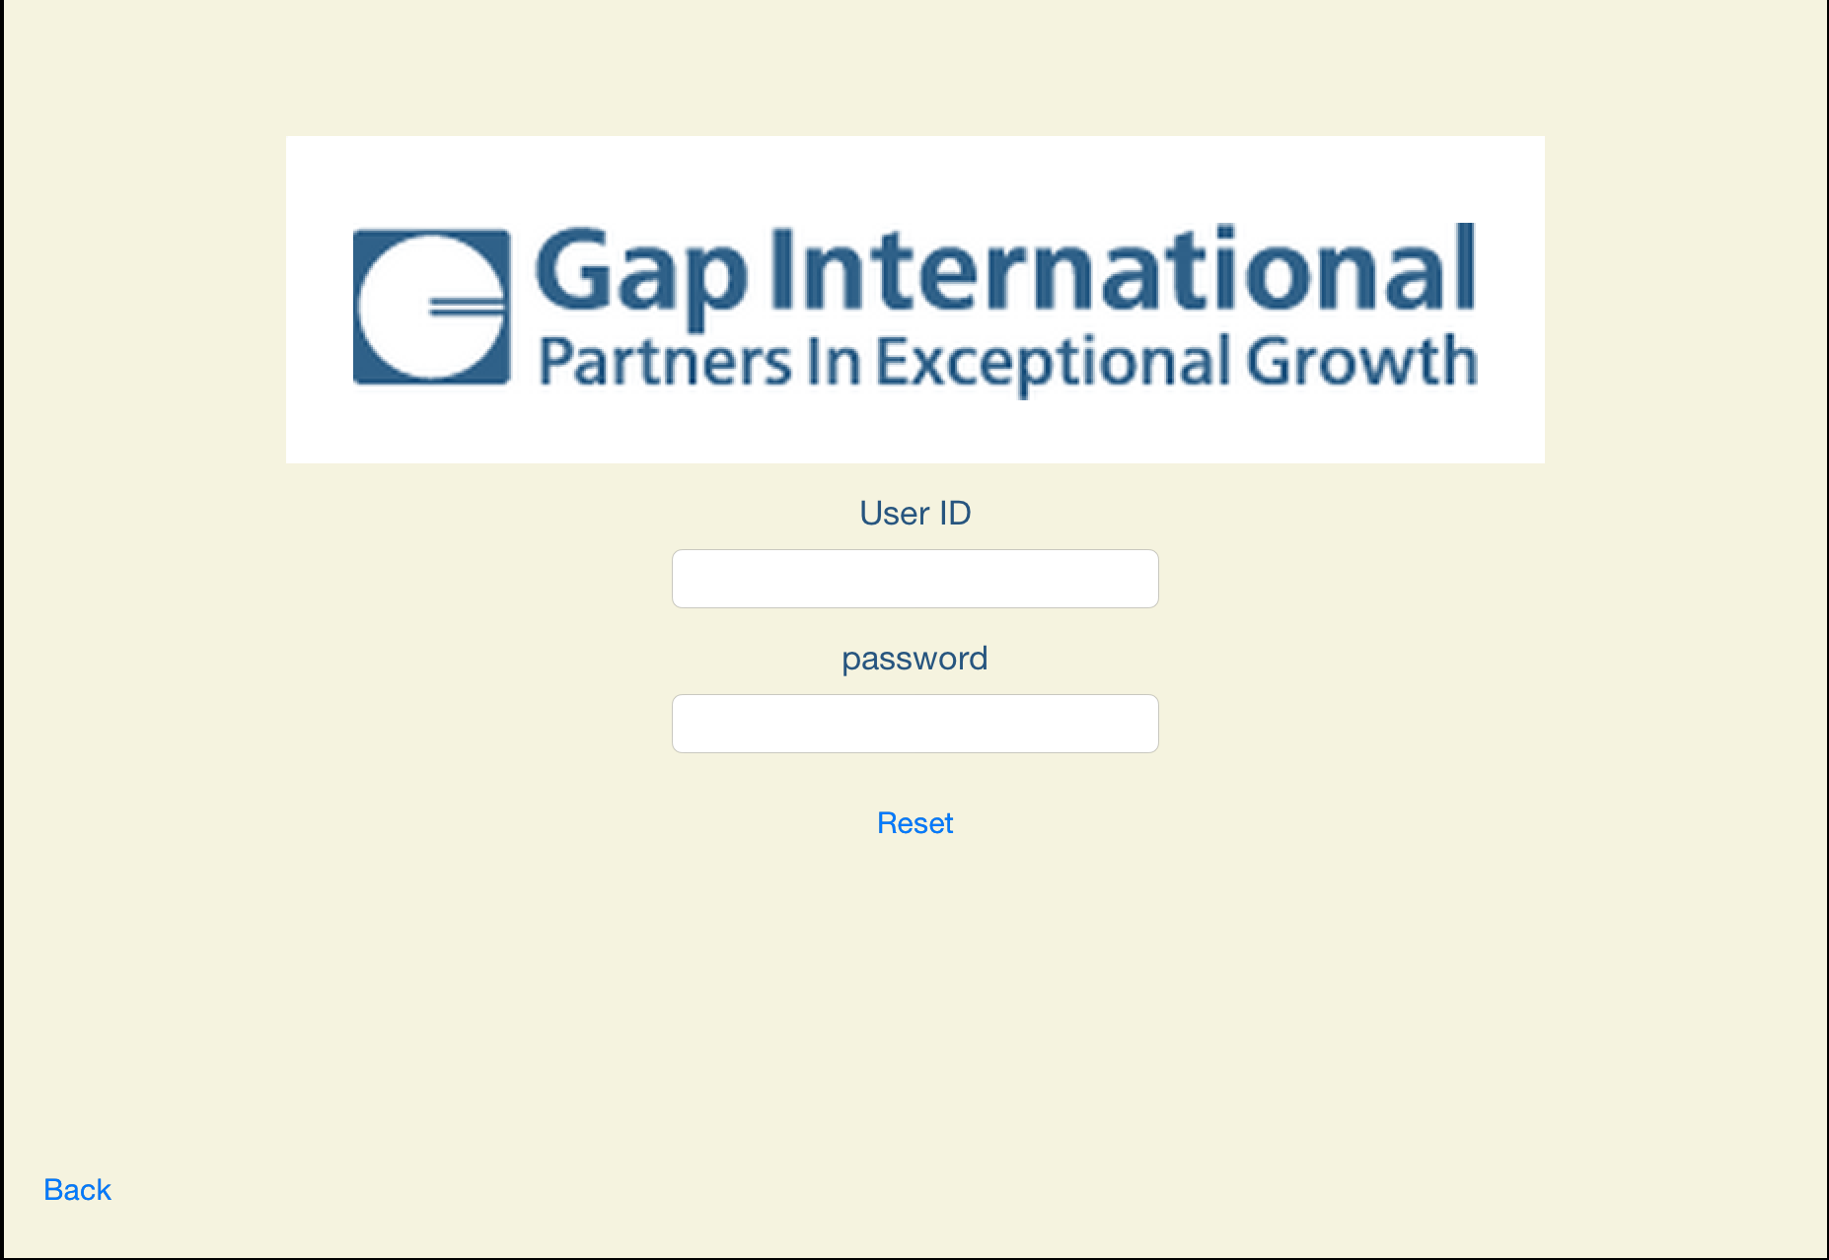**Reset Page Design**

**Elements:**

Background: light yellow(the same as the website)

Company logo: middle on top, 638x166

“User ID” label and “password” label : blue text, size 20

“userID” input text field: size 14

“password” input text field: size 14, secure text entry

“reset” button:

blue font, send request to reset, pop out a window, login and segue to video page

“Back” Button:

Stop reset, segue back to the login/register page.

**Video Page Design**

In Landscape

Before login:

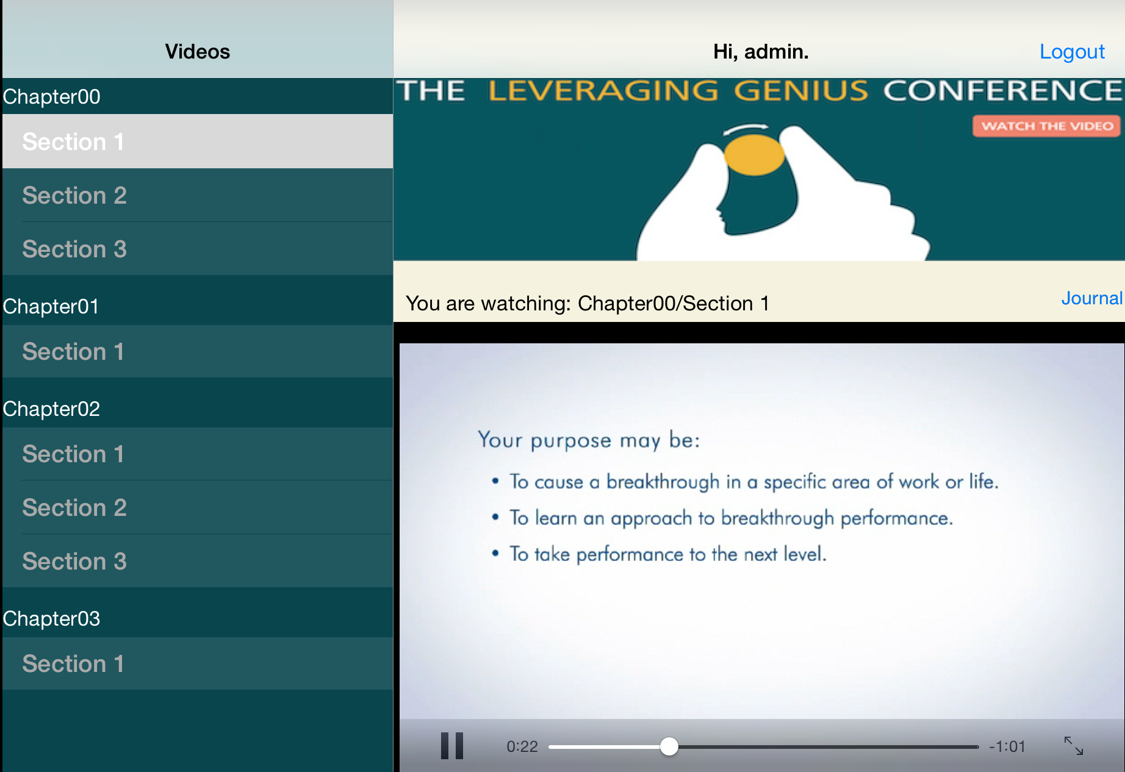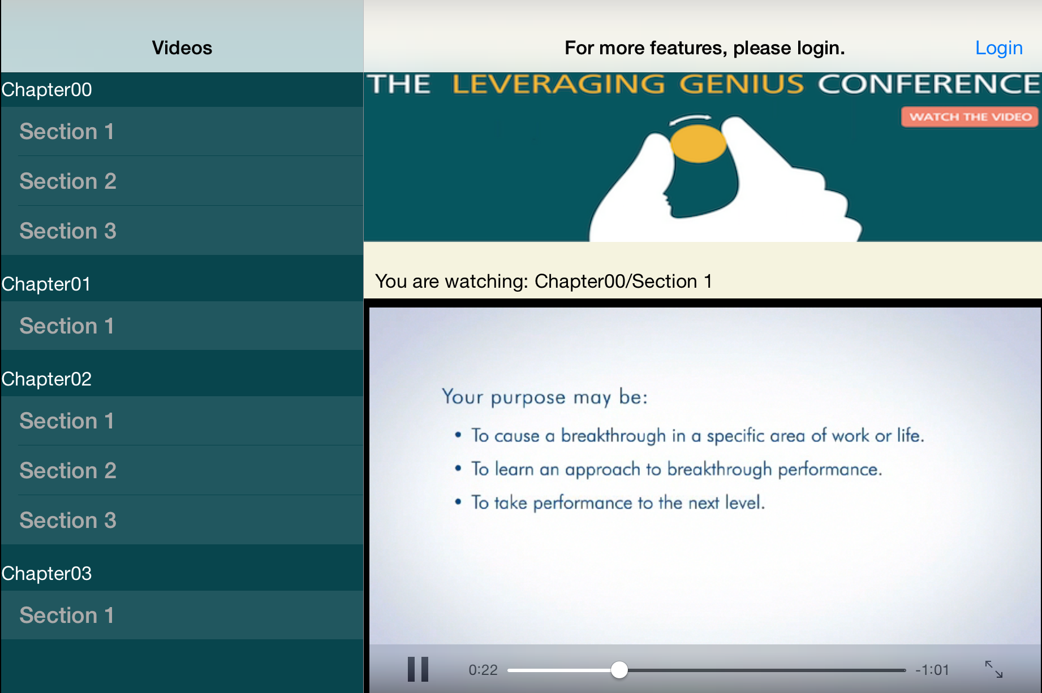

After login:

**Elements(Split view):**

*Master view(table view): 320x600, in Portrait it could be hidden*

Title: Video, in black

Table background: dark green

Cell Background: green

Cell header: height 40, text in white, chapter name

Cell content:

Section name, in light gray, click it and the video will show on the right

*Detail view:*

View Backgroud: light yellow

Navigation bar:

Title: “Hello, xxx”, xxx is the logined user ID

“Log out” button:

log out account and back to the login page

Banner: image on top under the navigation bar

Label: “You are watching xxx”, xxx is the video name

Video Player: play the video on web server using streaming technique

“Journal” button: (only be viewed after login)

blue text, on right under the banner

segue to the journal page

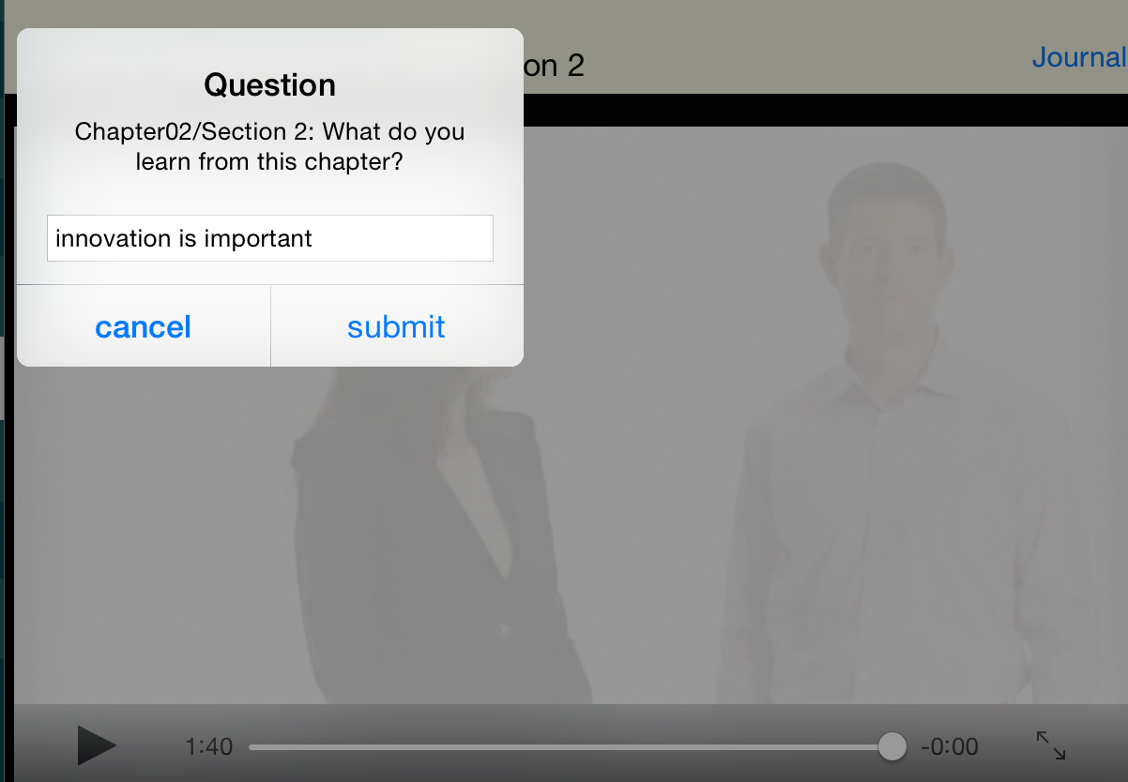

Pop out window:

Title: Queston

Message: “What do you learn from this chapter?”

Answer input box: input the answer

“submit” button: submit the answer to the web server

“cancel” button: do nothing

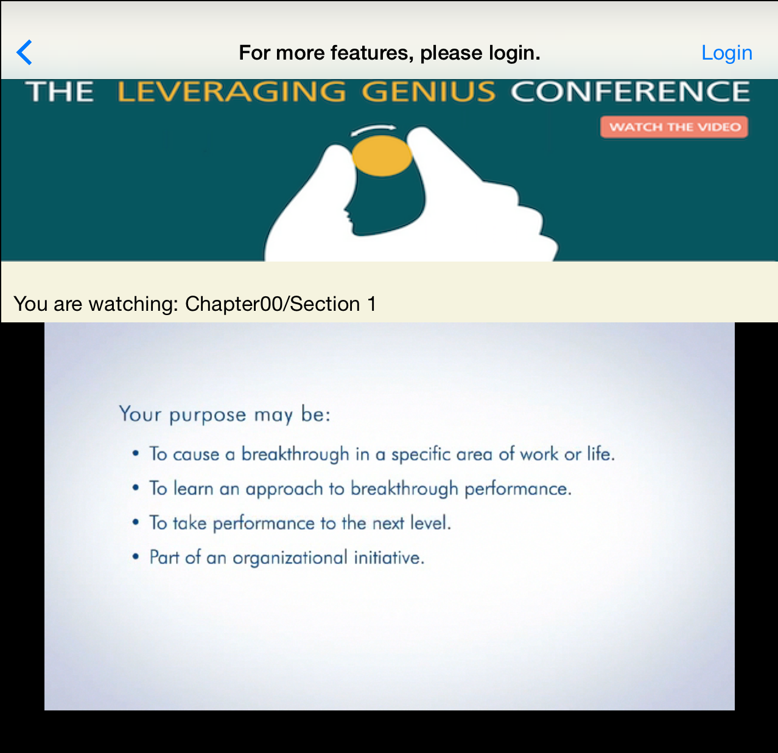

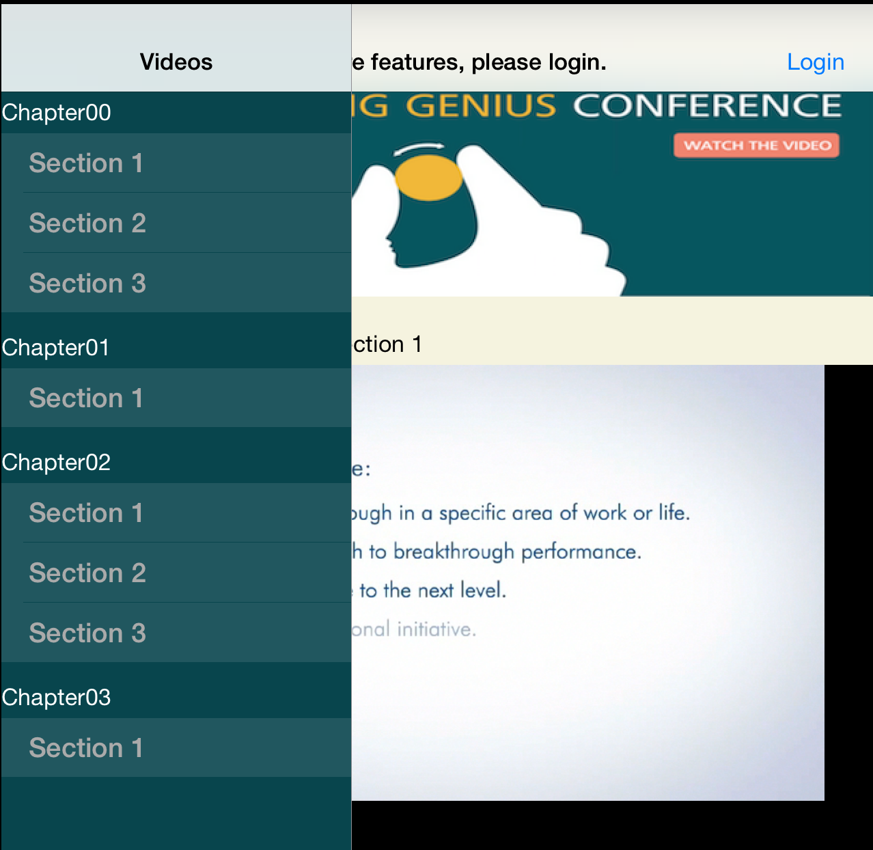In Portrait:

**Journal Page Design**

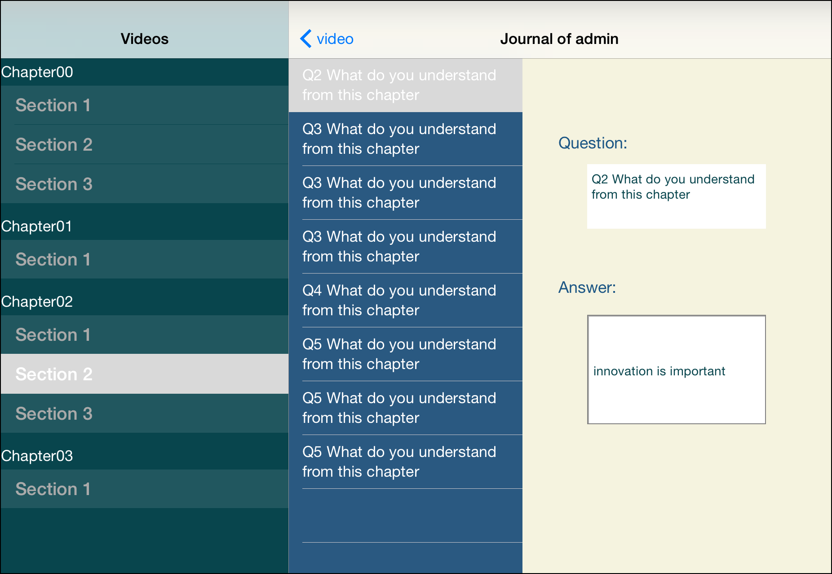

**Elements:**

*Master view(table view):* Same as Video Page

*Table view:*

Cell: background in ocean blue, content is question detail, text in white

Cells Separator: white single line

*Detail view:(show the question and answer of the selected cell)*

Navigation bar:

Title: “Journal of xxx”, xxx is the User ID

Back button: “Video”, back to the video page

View Background: light yellow

“Question” and “Answer” label: in blue, size 18

“Question” and “Answer” text field: text size 14, in blue, white background